Daylight Saving Time Update for Canadian Providences (British Columbia, Alberta, Northwest Territories, and Manitoba)

Contents
Introduction 2
14000 Series Transmitters 4
XR Series Transmitters 8
Wireless Tone Generator (WTG) 13
GPS String Simulator – Time Source for CompuSync 15
OneVue Transmitter – Standalone Mode Configuration (Internal and External Antenna, Main Transmitter configured for GPS or NTP, Repeater Transmitters configured for NTP) 16
OneVue Transmitter – OneVue Monitor Configuration (Internal and External Antenna, GPS and/or NTP, Main Transmitters and Repeater Transmitters) 18
PoE and WiFi Clocks (Analog or Digital) 20
Bluetooth Clocks with PoE or WiFi Bridges 21
PoE Bell Controllers 23
Standalone InfoBoards Using NTP for Time 24
OneVue Configured InfoBoards 26

Introduction
British Columbia (BC), Alberta (AB), Northwest Territories (NWT), and Manitoba (MB) have permanently switched to year-round daylight saving time on 8 March 2026, meaning the province will no longer change its clocks twice a year.

Key Details of the Change for British Columbia
- The Final Clock Shift: Clocks moved forward an hour on Sunday, 8 March 2026, which was BC’s final time change.
- No Fall Back: On 1 November 2026, clocks will remain the same instead of turning back an hour.
- Year-Round Offset: BC now stays on Pacific Time (UTC-7) all year long.

Additional Information: https://www2.gov.bc.ca/gov/content/governments/celebrating-british-columbia/daylight-saving-time

Key Details of Change for Alberta and Northwest Territories
- No Fall Back: Clocks will not be set back by an hour in November 2026, meaning Alberta will stay on Mountain Daylight Time (MDT) year-round.
- Official Name: The permanent year-round time zone is branded as Alberta Time (ABT) and Northwest Territories Time (NWT).
- No More Spring Forward: Biannual switches are officially canceled going forward.

Additional Information: https://www.alberta.ca/albertas-new-time-system-abt
Additional Information: https://www.cbc.ca/news/canada/north/nwt-ends-daylight-saving-9.7170964

Key Details for Change for Manitoba
- Announcement Date: September 17, 2026, by Premier Wab Kinew
- The Decision: Manitobans will remain on summer/daylight time year-round, meaning brighter winter evenings but darker winter mornings.
- Public Support: A May 2026 public survey showed 92% of nearly 72,000 respondents wanted to end seasonal clock changes, with 58% favoring permanent daylight saving time.

Additional Information: https://news.gov.mb.ca/news/index.html?item=75397&posted=2026-09-17

Primex Sync and Notify devices will need to be updated to reflect the daylight saving time update. Find your product/products below and follow the instructions to ensure your devices are updated correctly prior to 1 November 2026.

If you have any questions or need further assistance, please contact Primex Technical Support, Monday – Friday, 7 AM – 5 PM Central Time.
Phone: 1 (262) 729-4860 option 3
Email: service@primexinc.com

14000 Series Transmitters

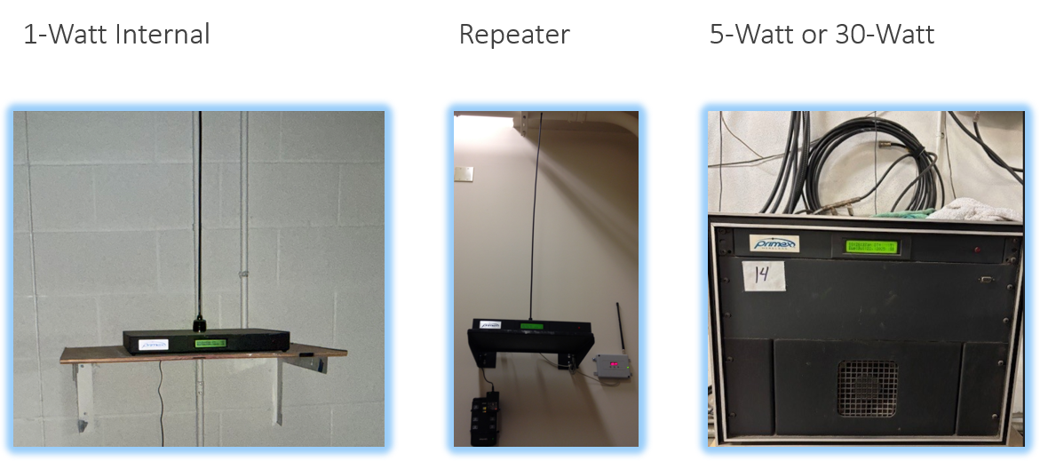

Main transmitters that are GPS controlled will need settings updated to ensure the proper operation after 2 AM local time on 1 November 2026.

Current Transmitter Configuration:
BC: Typical setup with Time Zone dial set to 8 (arrow pointing to 8 – Orange box in photo below) and daylight saving switch set to ON (UP – Green arrow in photo below)

AB and NWT: Typical setup with Time Zone dial set to 7 (arrow pointing to 7 – Orange box in photo below) and daylight saving switch set to ON (UP – Green arrow in photo below)

MB: Typical setup with Time Zone dial set to 6 (arrow pointing to 6 – Orange box in photo below) and daylight saying switch set to ON (UP – Green arrow in photo below)

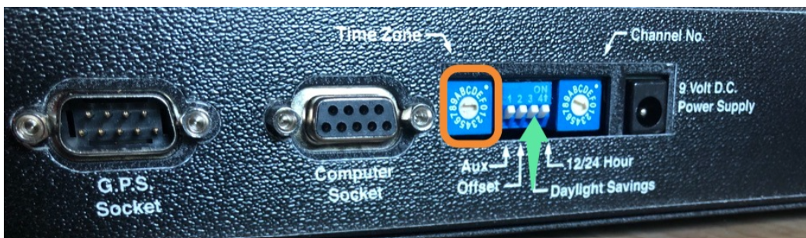
Typical front display with DT+ or similar (signifying Daylight Saving Time)

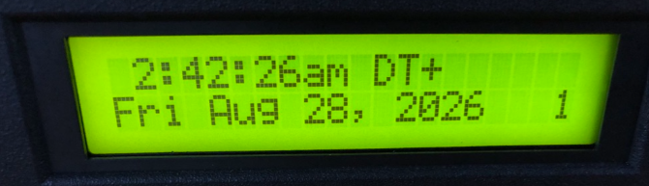

New Transmitter Configuration to reflect Daylight Saving Time update:

BC: Time Zone Dial set to 7 (Arrow pointing to 7 – Orange box in the photo below and the daylight saving switch set to OFF (Down – Green arrow in the photo below)

AB and NWT: Time Zone Dial set to 6 (Arrow pointing to 6 – Orange box in the photo below and the daylight saving switch set to OFF (Down – Green arrow in the photo below)

MB: Time Zone Dial set to 5 (Arrow pointing to 5 – Orange box in the photo below) and the daylight saving switch set to OFF (Down – Green arrow in the photo below)

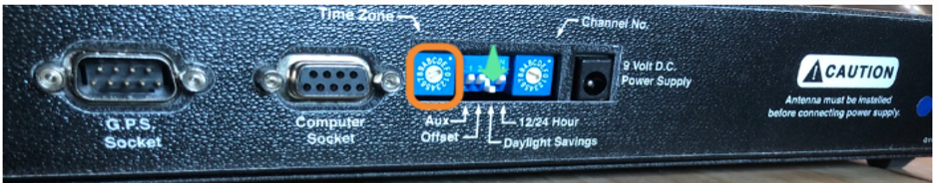

The front display of the transmitter should display the correct date/time but the DT+ should no longer be displayed.

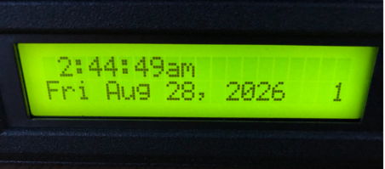

Step by Step Instructions:
- 14000 Series Transmitter with Attached Antenna and GPS
  - Turn the daylight saving switch to the off position (Down).
  - Turn the Time Zone dial to 7 for BC, to 6 for AB and NWT, and to 5 for MB.
  - If the time is correct on the display (UTC -7 for BC and UTC -6 for AB and NWT and UTC -5 for MB), the change is successful.
  - If the time is not correct, a power cycle may be necessary to force the switches to be read/corrected.
- 14000 Series Transmitter with External Antenna and GPS
  - Turn the daylight saving switch to the off position (Down).
  - Install the Primex Production Config Tool. This program is necessary to make the time zone change.
    - The installation is not straightforward as it does not have an install program.
    - It is recommended to contact Primex Technical Support to walk through this process.
  - Hook up a computer with straight through serial cable and a USB to Serial Adapter (adapter is necessary for newer computer models without a serial port) to the Computer Socket on the back of the transmitter.
    - Primex does not sell the cable needed for the connection. Please source these cables at your own discretion.
      - Amazon Options:
        - Straight Through Serial Cable
        - USB to Serial Adapter
    - 5-Watt and 30-Watt transmitters may have a serial port on the front of the transmitter box that serves as the computer port (depending on the vintage). If a serial port exists on the front of the transmitter, it is recommended to try that port first.
  - Open the Primex Production Config Tool to check the necessary settings and change the time zone to 7 for BC, to 6 for AB and NWT, and to 5 for MB.
    - Select the TX Mode/High Power Settings Tab.
    - Query Time Zone then highlight the number it returns (8 in BC, 7 in AB and NWT, or 6 in MB) and update to 7 in BC, 6 in AB and NWT, or 5 in MB.
    - Select Set Time Zone.
    - Query Time Zone to ensure the change took place.
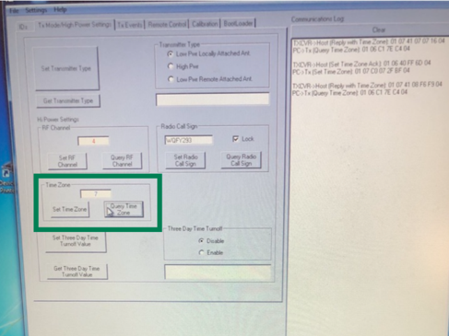
- If the time is correct on the display (UTC -7 for BC, UTC -6 for AB and NWT, and UTC -5 for MB), the change is successful.
- If the time is not correct, a power cycle may be necessary to read the new values.
- 14000 Repeater Transmitter
  - The repeater transmitter should already be set to pass the main transmitter’s time. Reconfiguration is NOT needed on the transmitter itself.
  - The grey repeater receiver (plugged into the GPS port of the transmitter) will need to have the DST Bypass switch turned ON.
- Unscrew the two Phillips Head Screws securing the top of the case and find the 8 pin dip switch bank (typically red or blue).
- Flip the DST Disable Switch (#5) to the ON position
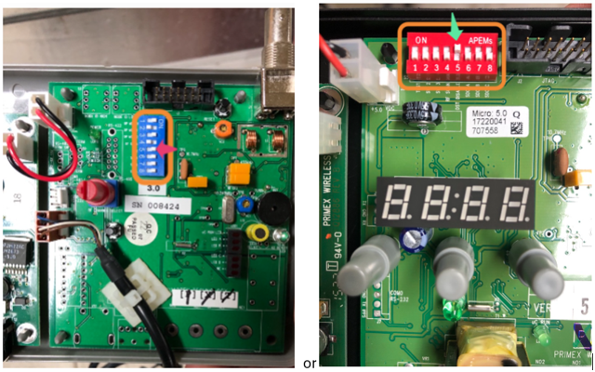
- Place the top back on and secure with the screws.
- Power cycling the repeater receiver is necessary to ensure changes take effect.
  - Repeaters only look to update their time once an hour, so the change may take time to propagate through the system.
  - To see immediate change, power cycle the main transmitter after making all configuration changes then power cycle each repeater starting from the closest to the main transmitter and ending with the repeater furthest from the main transmitter.
    - Ensure time on the repeater is displayed correctly before moving to the next repeater.
    - Repeaters have a grey receiver switch connected to them which act as the time source. If power cycling, and the grey box has an independent power supply from the transmitter, please disconnect both the transmitter and the grey box power supply. Wait for 10 seconds, then plug in the transmitter first, wait 10 seconds then plug in the repeater. This will ensure the transmitter is fully booted and ready for a time signal from the repeater.

XR Series Transmitters

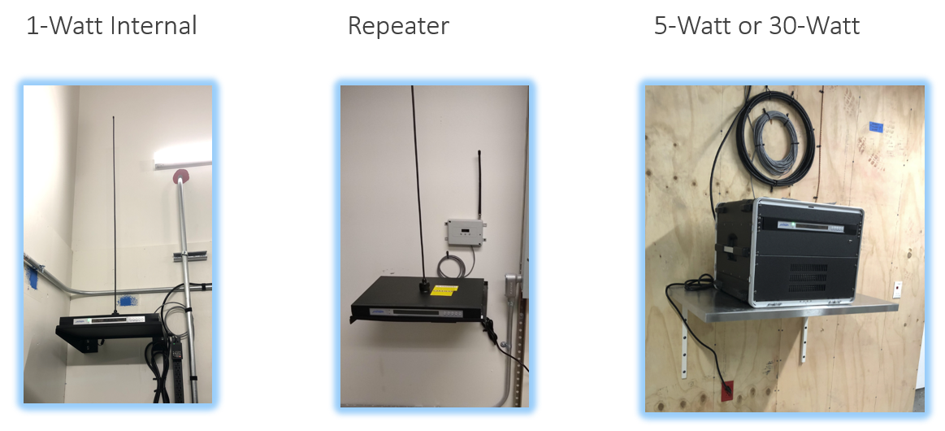

Main transmitters that are GPS or NTP controlled will need settings updated to ensure proper operation after 2 AM local time on 1 November 2026.

Current Transmitter Configuration:

BC: Typical setup with Time Zone dial set to 8 (Arrow pointing to 8 – Orange box in the photo below) and daylight saving switch set to DST (Down – Green arrow in the photo below)

AB and NWT: Typical setup with Time Zone dial set to 7 (Arrow pointing to 7– Orange box in the photo below) and daylight saving switch set to DST (Down – Green arrow in the photo below)

MB: Typical setup with Time Zone dial set to 6 (Arrow pointing to 6 – Orange box in the photo below) and daylight saving switch set to DST (Down – Green arrow in the photo below)

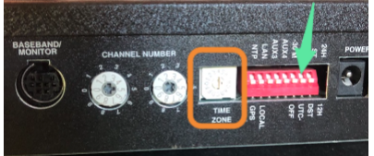

Typical front display with DT or similar (signifying Daylight Saving Time). Also note, P for Pacific Time in BC, M for Mountain Time in AB and NWT, and C for Central Time in MB.

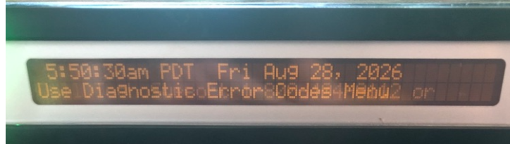

New Transmitter Configuration to reflect Daylight Saving Time update:

BC: Time Zone Dial set to 7 (Arrow pointing to 7 – Orange box in photo below) and daylight saving switch set to ST (Up – Green arrow in photo below)

AB and NWT: Time Zone Dial set to 6 (Arrow pointing to 6 – Orange box in photo below) and daylight saving switch set to ST (Up – Green arrow in photo below)

MB: Time Zone Dial set to 5 (Arrow pointing to 5 – Orange box in photo below) and daylight saving switch set to ST (Up – Green arrow in photo below)

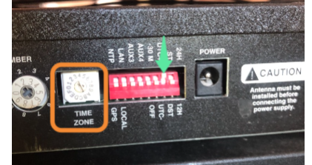

The front display of the transmitter should have the correct time displayed but DT is no longer on the display. Also note, M for Mountain Time in BC, C for Central in AB and NWT, and E for MB. **NOTE** This is going to be wrong on the front of the transmitter as BC is staying in the Pacific Daylight Time, AB and NWT are staying in Mountain Daylight Time, and MB is staying in Central Daylight Time.

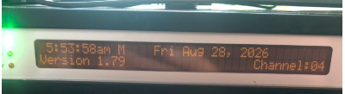

Step by Step Instructions
- XR Transmitter with Internal Antenna and GPS or NTP
  - Turn the DST switch to the ST position (UP).
  - Turn the Time Zone Dial to 7 in BC, 6 in AB and NWT, or 5 in MB.
  - If the time is correct on the display (UTC -7 in BC, UTC -6 in AB and NWT, or UTC -5 in MB), the change is successful.
  - If the time is not correct, a power cycle may be necessary to force the switches to be read/corrected.
- XR Transmitter with External Antenna with GPS or NTP
- Turn the daylight saving switch to the off position (Down).
- Install the Primex Production Config Tool. This program is necessary to make the time zone change.
    - The installation is not straightforward as it does not have an install program.
    - It is recommended to contact Primex Technical Support to walk through this process.
- Hook up a computer with straight through serial cable and a USB to Serial Adapter (adapter is necessary for newer computer models without a serial port) to the Computer Socket on the back of the transmitter.
    - Primex does not sell the cable needed for the connection. Please source these cables at your own discretion.
      - Amazon Options:
        - Straight Through Serial Cable
        - USB to Serial Adapter
    - 5-Watt and 30-Watt transmitters may have a serial port on the front of the transmitter box that serves as the computer port (depending on the vintage). If a serial port exists on the front of the transmitter, it is recommended to try that port first.
- Open the Primex Production Config Tool to check the necessary settings and change the time zone to 7 in BC, 6 in AB and NWT, or 5 in MB.
- Select the TX Mode/High Power Settings Tab.
- Query Time Zone then highlight the number it returns (8 in BC, 7 in AB and NWT, or 6 in MB) and update it to 7 in BC, 6 in AB and NWT, or 5 in MB.
- Select Set Time Zone.
- Query Time Zone to ensure the change took place.
- If the time is correct on the display (UTC -7 in BC, UTC -6 in AB and NWT, or UTC -5 in MB), the change is successful.
- If the time is not correct, a power cycle may be necessary to read the new values.
- XR Repeater Transmitter
  - The repeater transmitter should already be set to pass the main transmitter’s time. Reconfiguration is NOT needed on the transmitter itself.
  - The grey repeater receiver (plugged into the GPS port of the transmitter) will need to have the DST Bypass switch turned ON.
- Unscrew the two Phillips Head Screws securing the top of the case and find the 8 pin dip switch bank (typically red or blue).
- Flip the DST Disable Switch (#5) to the ON position
- Place the top back on and secure with the screws.
- Power cycle the repeater receiver is necessary to ensure changes take effect.
  - Repeaters only look to update their time once an hour, so the change may take time to propagate through the system.
  - To see immediate change, power cycle the main transmitter after making all configuration changes then power cycle each repeater starting from the closest to the main transmitter and ending with the repeater furthest from the main transmitter.
    - XR Transmitters have a capacitor that holds the time through short outages – to clear the time off the display and force it to start at 12AM, use the arrows on the panel to navigate to the Settings / GPS Menu. Go down until Transmitter Reset is found, then select it by hitting enter. Reset power.
    - Repeaters have a grey receiver switch connected to them which act as the time source. If power cycling, and the grey box has an independent power supply from the transmitter, please disconnect both the transmitter and the grey box power supply. Wait for 10 seconds, then plug in the transmitter first, wait 10 seconds then plug in the repeater. This will ensure the transmitter is fully booted and ready for a time signal from the repeater.
    - Ensure time on the repeater is displayed correctly before moving to the next repeater.
    - If the transmitter and repeater share the same power supply, unplug the shared supply, wait 10 seconds, then plug it back in.

Wireless Tone Generator (WTG)

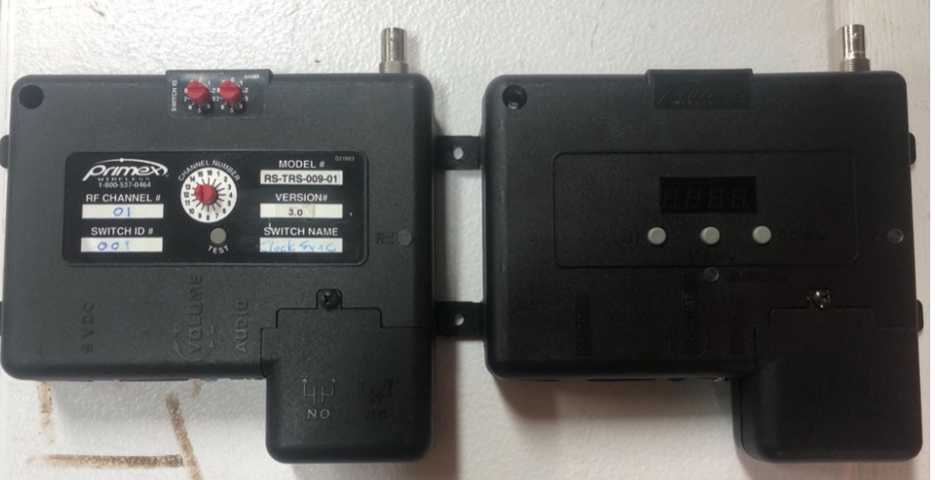

For the WTG, turn the DST bypass switch ON.
1. Unscrew the two Phillips Head screws securing the top of the case as shown below.
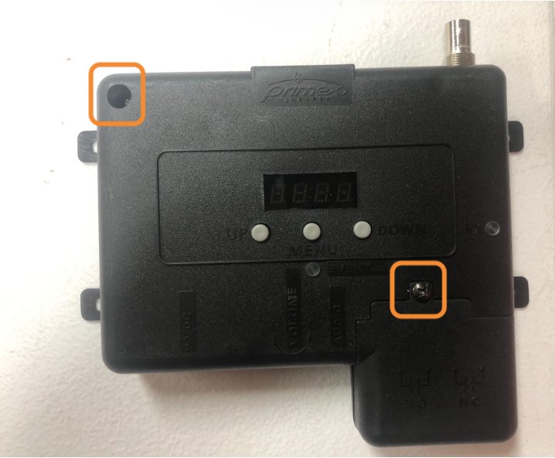
2. Remove the lower cover to expose the relay block.
WARNING: If the block is in use (wires running to it), please use caution. Primex recommends powering down the equipment connected during this process for safety reasons.
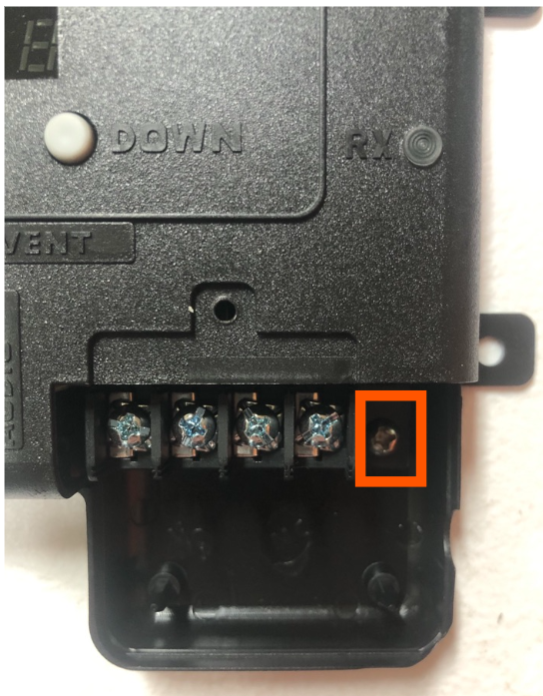
3. Find the 8-pin dip switch back (typically red or blue).
4. Flip the DST Disable Switch (#5) to the ON position.
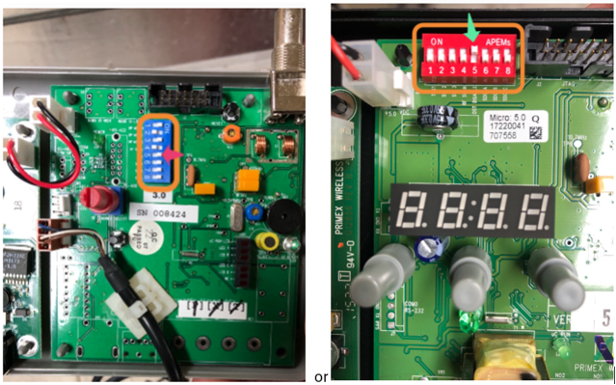
5. Place the top back on and secure with the screws.
6. Turn power on to the attached equipment (if applicable).
7. Power cycle the WTG to ensure changes take effect.

GPS String Simulator – Time Source for CompuSync

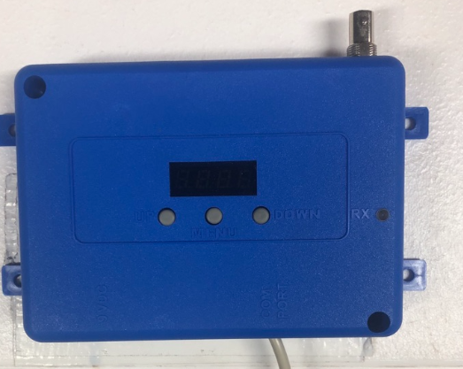
For the GPS String Simulator, turn the DST Bypass switch ON.
- Unscrew the two Phillips Head screws securing the top of the case as shown below.
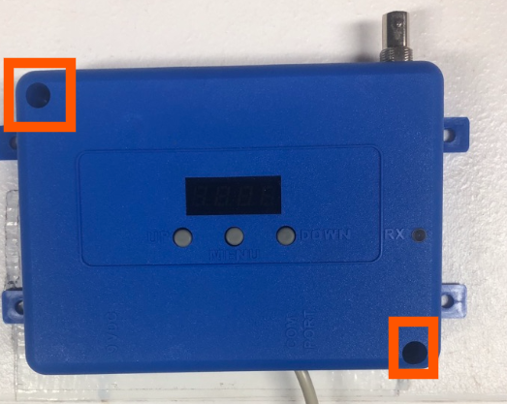
2. Remove the top of the case and find the 8-pin dip switch bank (typically red or blue).
3. Flip the DST Disable Switch (#5) to the ON position.
4. Place the top back on and secure with the screws.
5. Power cycle the GPS String Simulator to ensure the changes take effect.

OneVue Transmitter – Standalone Mode Configuration (Internal and External Antenna, Main Transmitter configured for GPS or NTP, Repeater Transmitters configured for NTP)

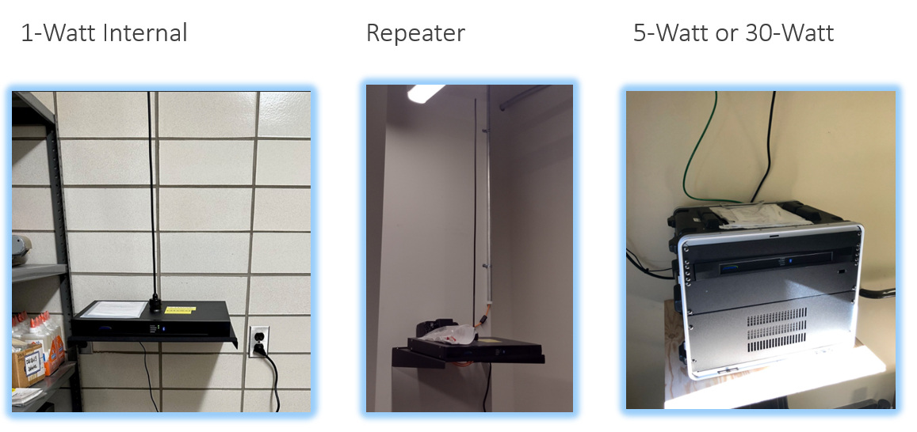
The main OneVue transmitter will need an update to its time zone setting. All repeater transmitters that are set to receive time from NTP and not from another transmitter, will also need an update to its time zone setting.

- Download the OneVue Device Configurator (ODC) app from the App Store (iOS) or Play Store (Android). The updated app with the correct time zone configuration will be released on XX XXX XXXX. The app version is 1.7.22. Please ensure you have this version of the app to write the correct time zone configuration to your device(s).

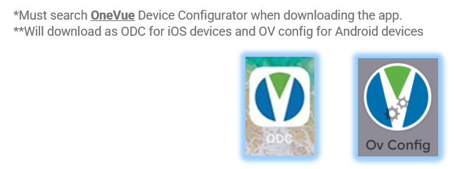
- Open the ODC app and select “Standalone Configuration.”
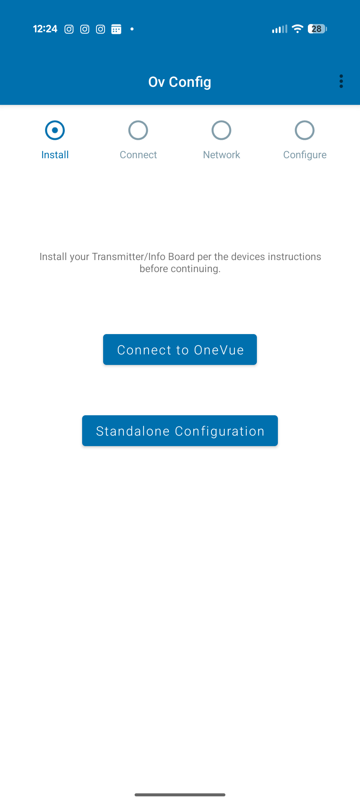
- Press the “Bluetooth” button on the front of the transmitter.
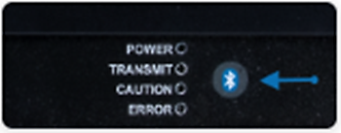
- Select the transmitter on the app once it appears.
- Select “Continue” on the Network screen.
- On the Configure screen, update the Time Zone to “Vancouver” in BC, “Edmonton” in AB and NWT, or “Winnipeg” in MB.
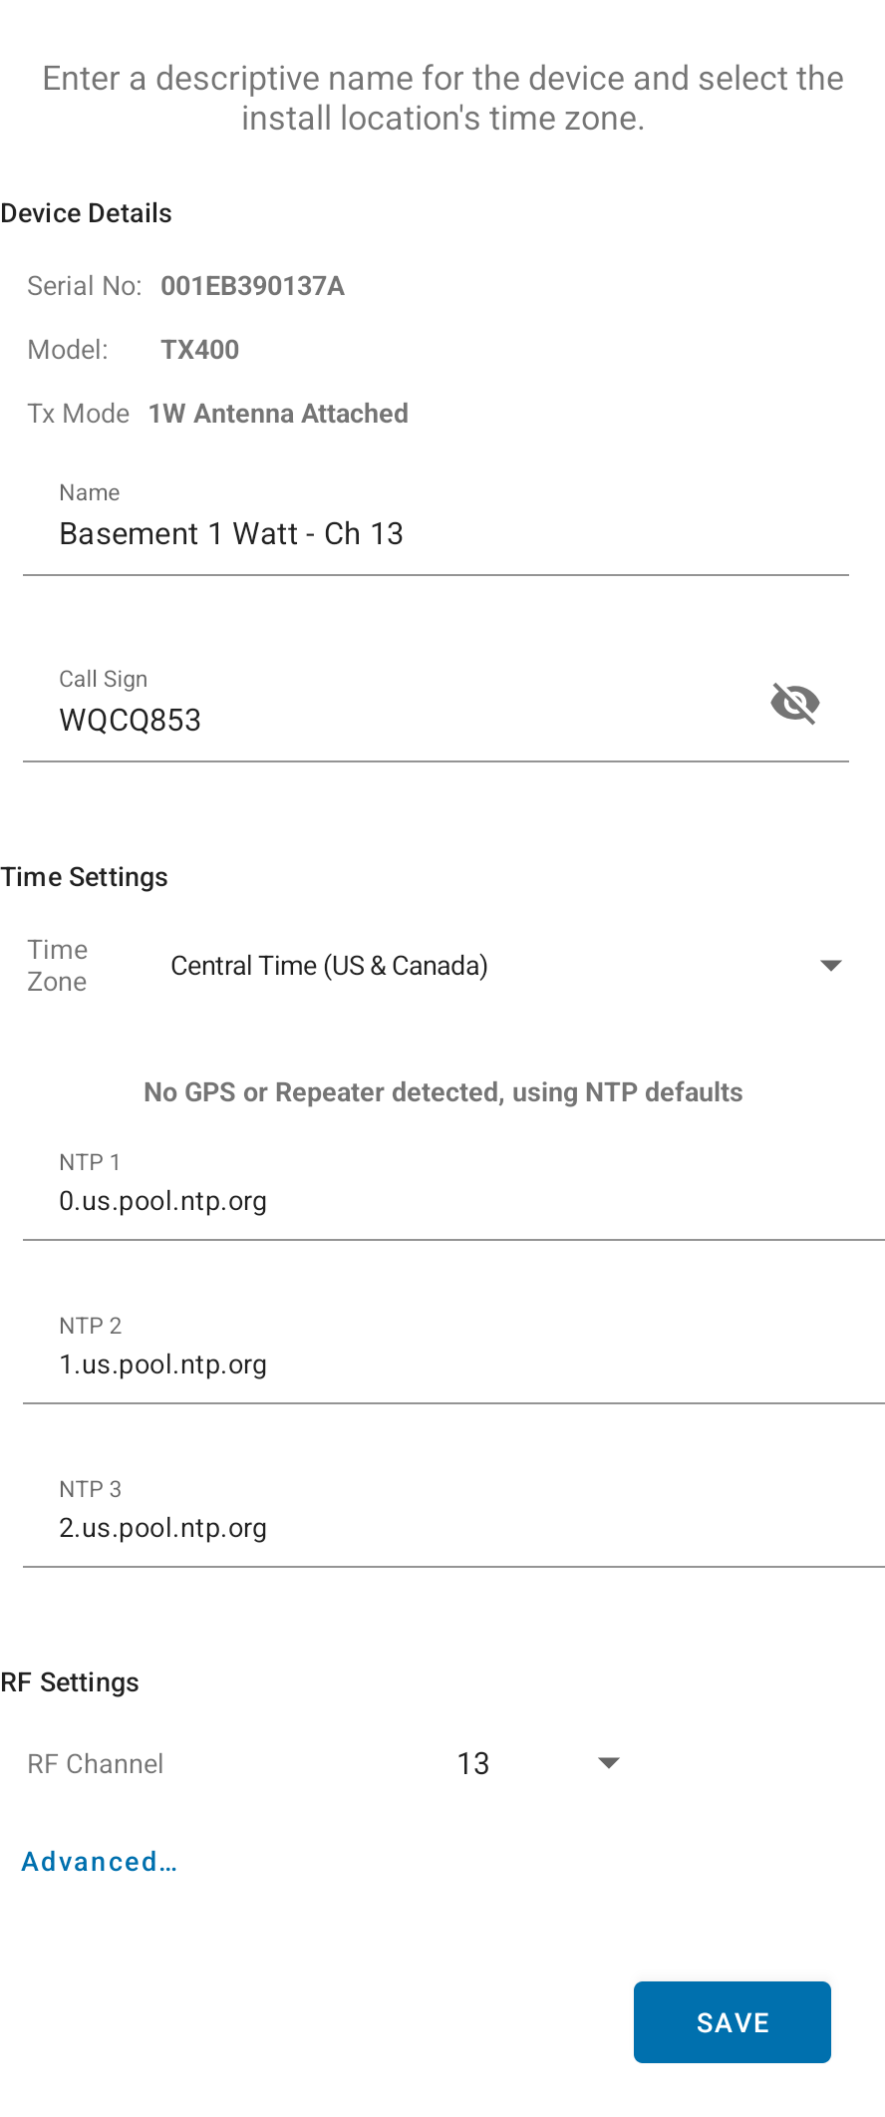
- Select Save.
- Contact Primex Technical Support for any assistance in troubleshooting the transmitters.

OneVue Transmitter – OneVue Monitor Configuration (Internal and External Antenna, GPS and/or NTP, Main Transmitters and Repeater Transmitters)

Once the time zone is updated on the OneVue account, no other configuration changes are needed. Please ensure all transmitters are online, in a “Normal” state, and have a current “Last Check-In.”

- Login to OneVue.
- Go to Admin > Edit Account Name.
- Verify the Time Zone is set to Vancouver in BC, Edmonton in AB and NWT, or Winnipeg.
    - If the time zone is not set to Vancouver, Edmonton, or Winnipeg, choose Vancouver, Edmonton, or Winnipeg from the dropdown menu.
    - Save the new Account configuration.

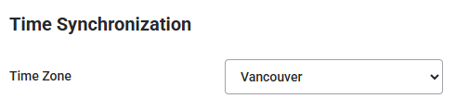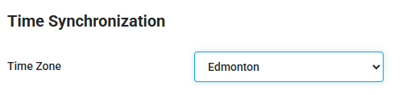
- Go to Devices > Transmitters.
- Verify there are no transmitters with a Status of Unresponsive.
    - Unresponsive means the transmitter is not checking in or communicating to OneVue and will not be able to download the time zone update.
    - This needs to be resolved to ensure the transmitter updates to the correct time zone.
- Verify the “Last Check-In” is current.
    - By default, transmitters check-in every 5 minutes
    - The date should be “today’s” date, the time will be within the last 5 – 60 minutes depending on the Check-in Interval set on the Gateway Profile of the transmitter.
- The “Update Pending” column should show “Yes” if the time zone update has not been downloaded. The “Update Pending” column should switch to “No” once the time zone update has been downloaded.
- Contact Primex Technical Support for any assistance in troubleshooting the transmitters.

PoE and WiFi Clocks (Analog or Digital)

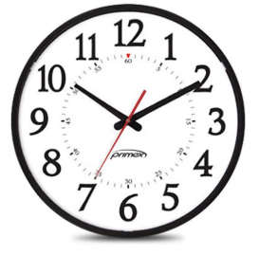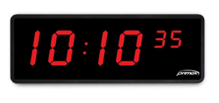
Once the time zone is updated on the OneVue account, no other configuration changes are needed. Please ensure all clocks are online, in a “Normal” state, and a current “Last Check-In.”

- Login to OneVue.
- Go to Admin > Edit Account Name.
- Verify the Time Zone is set to Vancouver in BC, Edmonton in AB and NWT, or Winnipeg for MB.
  - If the time zone is not set to Vancouver, Edmonton, or Winnipeg, choose Vancouver, Edmonton. Or Winnipeg from the dropdown menu.
  - Save the new Account configuration.
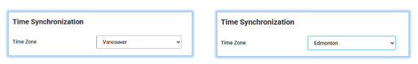
- Go to Devices > Clocks.
- Verify there are no clocks with a Status of Unresponsive.
  - Unresponsive means the clock is not checking in or communicating to OneVue and will not be able to download the time zone update.
  - This needs to be resolved to ensure the clock updates to the correct time zone.
- Verify the “Last Check-In” is current.
  - By default, clocks check-in every day between 12 AM – 6 AM local time.
- The “Update Pending” column should show “Yes” if the time zone update has not been downloaded. The “Update Pending” column should switch to “No” once the time zone update has been downloaded.
- Contact Primex Technical Support for any assistance in troubleshooting the clocks.

Bluetooth Clocks with PoE or WiFi Bridges

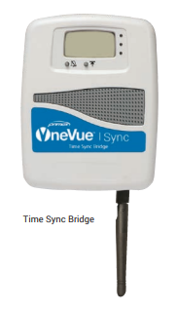
Once the time zone is updated on the OneVue account, no other configuration changes are needed. Please ensure all bridges and clocks are online, in a “Normal” state, and a current “Last Check-In.”

- Login to OneVue.
- Go to Admin > Edit Account Name.
- Verify the Time Zone is set to Vancouver in BC, Edmonton in AB and NWT, or Winnipeg in MB.
  - If the time zone is not set to Vancouver, Edmonton, or Winnipeg, choose Vancouver, Edmonton, or Winnipeg from the dropdown menu.
  - Save the new Account configuration.
- Go to Devices > Bridges.
- Verify there are no bridges with a Status of Unresponsive.
  - Unresponsive means the bridge is not checking in or communicating to OneVue and will not be able to download the time zone update.
  - This needs to be resolved to ensure the bridge/clocks update to the correct time zone.
  - The bridges need to be resolved before the clocks can be reviewed and resolved.
- Verify the “Last Check-in” is current.
  - Bridges are set to a specific “wake-up” time by Primex. This is a daily wake-up time.
  - If the bridges have a “Last Check-in” in the last 24 hours, they are syncing correctly.
- Go to Devices > Clocks.
- Verify there are no clocks with a Status of Unresponsive.
  - Unresponsive means the clock is not checking in or communicating to a bridge and will not be able to download the time zone update.
  - This needs to be resolved to ensure the clock updates to the correct time zone.
  - If you recently resolved an Unresponsive bridge, wait until the next wake-up time to review the clock statuses.
- Verify the “Last Check-In” is current.
  - By default, clocks check-in with the bridge every day at the set wake-up time.
  - If the clocks have a “Last Check-In” in the last 24 hours, they are syncing correctly.
- The “Update Pending” column should show “Yes” if the time zone update has not been downloaded. The “Update Pending” column should switch to “No” once the time zone update has been downloaded.
- Contact Primex Technical Support for any assistance in troubleshooting the clocks.

PoE Bell Controllers

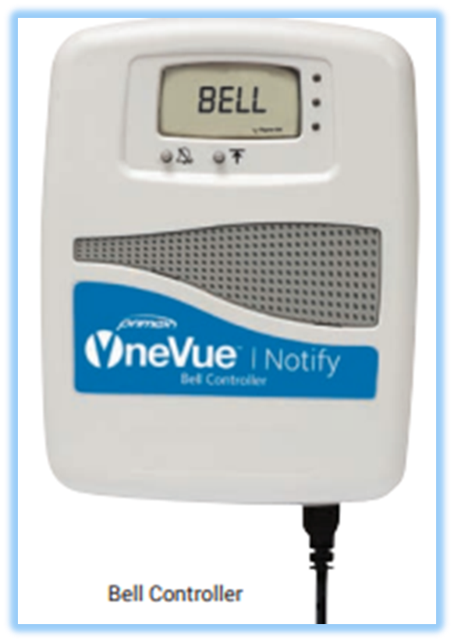
Once the time zone is updated on the OneVue account, no other configuration changes are needed. Please ensure all bell controllers are online, in a “Normal” state, and a current “Last Check-In.”

- Login to OneVue.
- Go to Admin > Edit Account Name.
- Verify the Time Zone is set to Vancouver in BC, Edmonton in AB and NWT, or Winnipeg in MB.
  - If the time zone is not set to Vancouver, Edmonton, or Winnipeg, choose Vancouver, Edmonton, or Winnipeg from the dropdown menu.
  - Save the new Account configuration.
- Go to Devices > Bell Controllers.
- Verify there are no bell controllers with a Status of Unresponsive.
  - Unresponsive means the bell controller is not checking in or communicating to OneVue and will not be able to download the time zone update.
  - This needs to be resolved to ensure the bell controller updates to the correct time zone.
- Verify the “Last Check-In” is current.
  - By default, bell controller check-in every hour.
- The “Update Pending” column should show “Yes” if the time zone update has not been downloaded. The “Update Pending” column should switch to “No” once the time zone update has been downloaded.
- Contact Primex Technical Support for any assistance in troubleshooting the clocks.

Standalone InfoBoards Using NTP for Time

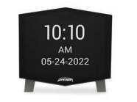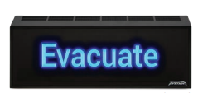
Each InfoBoard will need an update to its time zone setting. InfoBoards using the transmitter for time will update to the transmitters time. No additional configuration is needed for InfoBoards using the transmitter for time.

- Download the OneVue Device Configurator (ODC) app from the App Store (iOS) or Play Store (Android). The updated app with the correct time zone configuration will be released on XX XXX XXXX. The app version is 1.7.22. Please ensure you have this version of the app to write the correct time zone configuration to your device(s).
- Open the ODC app and select “Standalone Configuration.”
- Press the “Bluetooth” button on the back of the InfoBoard.
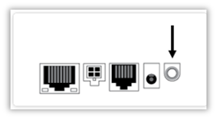
- Select the InfoBoard on the app once it appears.
- Select “Continue” on the Network screen.
- On the Configure screen, update the Time Zone to “Vancouver” in BC, “Edmonton” in AB and NWT, or “Winnipeg” in MB.
- Select Save.
- Contact Primex Technical Support for any assistance in troubleshooting the transmitters.

OneVue Configured InfoBoards

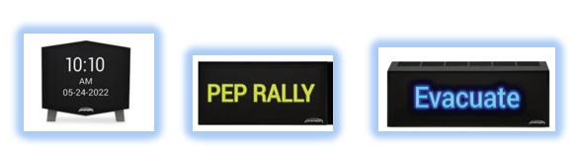
Once the time zone is updated on the OneVue account, no other configuration changes are needed. Please ensure all InfoBoards are online, in a “Normal” state, and a have current “Last Check-In.”

- Login to OneVue
- Go to Admin > Edit Account Name.
- Verify the Time Zone is set to Vancouver in BC, Edmonton in AB and NWT, or Winnipeg in MB.
  - If the time zone is not set to Vancouver, Edmonton, or Winnipeg, choose Vancouver, Edmonton, or Winnipeg from the dropdown menu.
  - Save the new Account configuration.
- Go to Devices > InfoBoards.
- Verify there are no InfoBoards with a Status of Unresponsive.
  - Unresponsive means the InfoBoard is not checking in or communicating to OneVue and will not be able to download the time zone update.
  - This needs to be resolved to ensure the InfoBoard updates to the correct time zone.
- Verify the “Last Check-In” is current.
  - By default, InfoBoard fully checks in every day between 12 AM – 6 AM.
- The “Update Pending” column should show “Yes” if the time zone update has not been downloaded. The “Update Pending” column should switch to “No” once the time zone update has been downloaded.
- Contact Primex Technical Support for any assistance in troubleshooting the clocks.

